

CHURN PREDICTION IN

DODGE THE MUD GAME

Analysis of Customer Data

LE ANH THU PHAM, LAM MINH TRIET THIEN

INSTRUCTORS
dr. Julija Vaitonyte

LOCATION
Tilburg University
School of Humanities and Digital Sciences
Department of Cognitive Science & Artificial Intelligence
Tilburg, The Netherlands

WORD COUNT
[1496]
Churn Prediction in Dodge the Mud Game
Analysis of Customer Data

Le Anh Thu Pham (2131850), Lam Minh Triet Thien (2131937)

1. Problem definition
Dodge the Mud is a free mobile game in which players try to avoid falling mud. The dataset contains gameplay sessions from January 2015 to May 2016, consisting of 163,929 rows and three variables: device, score, and time. The time variable indicates Unix Epoch timestamps.
In the context of mobile games, churn refers to a player who permanently stops playing (Runge & Gao, 2014). To construct reliable labels for churn and non-churn, two-time windows are required: the Observation Period (OP) and the Churn Prediction Period (CP). The OP begins at the player’s first recorded session and continues for a defined number of days, during which the player’s early behavior is observed. The CP follows the OP and serves as the period for determining churn status. A player with at least one session within the CP is considered a non-churner, otherwise, they are a churner. These definitions form the foundation for building ground-truth labels.
The main purpose of this project is to build a machine pipeline to classify the churner and non-churner by (1) engineering features, (2) handling extreme class imbalance, (3) training three Machine Learning (ML) models, (4) hyperparameter tuning and (5) comparing models and interpreting predictions through SHAP analysis.

2. Methods
To achieve above goal, the following methodologies were applied:

2.1 EDA and Preprocessing Data
First, Unix timestamps were converted to datetime formats and split into components like months, day, time for EDA. Only nine missing device values were identified and removed, because it’s only a small portion of the dataset.
EDA focused on understanding temporal behavior (retention curve, learning curve), session patterns, and score distributions. These analyses helped estimate reasonable OP/CP windows by revealing typical player lifetimes and engagement patterns.

2.2 Churn Label Creation
Because churn labels depend on how OP/CP windows are defined, choosing suitable OP/CP windows is a foundation step for this project. Based on the EDA, OP/CP were chosen with the consideration of class imbalance and its definition. Short OP windows risk misclassifying non-churners, while short CP windows may mislabel players who simply take breaks. Moreover, after training models, to verify robustness, four OP/CP combinations were re-evaluated to check the performance for each combination and hence confirm the final choice.

2.3 Feature Engineering
Feature engineering focused on capturing early player behavior during the OP. With only 3 raw variables (device, score, time), feature engineering was critical. Too many features may cause noise, too little features in the other hand cannot capture all the pattern. Therefore, we tried to create a balance feature set including 24 features. Both basic and advanced behavioral features were created, divided into different groups: score features, session pattern, inter-session features. Afterwards, feature selection is done with 2 steps: low variance removal (threshold 1%) and pairwise correlation filtering with higher importance keep based on Random Forest ranking for pairs of features with correlations above 0.9.

2.4 Class Imbalance Handle and Models training
A major challenge of this project was severe class imbalance. For OP = 5 and CP = 10, churners accounted for 91%. Applying sampling method to the whole dataset like SMOTE would risk producing excessive, unrealistic synthetic samples. After trying different methods such as SMOTE, SMOTE-Tomek, SMOTEENN, SMOTEENN was the best approach for this dataset, but it is applied to only half of the data to avoid distortion. The resulting distribution on train dataset was more manageable (66% churn, 33% non-churn). More cost-sensitive learning was also applied to penalize misclassifications of the minority class more heavily

The data was then split into training and test sets, and models were evaluated using five-fold cross-validation. Three models were selected for training:
- Random Forest: A Random Forest is an ensemble of decision trees where each tree is trained on a bootstrapped sample of the data, and predictions are made through majority voting across trees (Breiman, 2001)
- XGBoost: a gradient boosting framework that constructs trees sequentially, with each tree trained to reduce the residual errors left by the previous ensemble (Chen & Guestrin, 2016).
- CatBoost: a gradient boosting algorithm designed to handle categorical features efficiently and reduce overfitting through ordered boosting and target statistics, leading to strong performance with minimal preprocessing (Dorogush, Ershov & Gulin, 2018).
These models were chosen because churn prediction typically relies on subtle behavioral patterns, and tree-based ensembles are well suited for capturing non-linear relationships without demanding extensive preprocessing.

2.5 Hyperparameter Tuning
Each model underwent hyperparameter optimization using randomized search approaches. The tuning process prioritized PR-AUC instead of ROC-AUC as we want to optimize the performance on the minor class.

2.6 Evaluation, Error Analysis, and SHAP Analysis
Model evaluation considered performance metrics like accuracy, precision, recall, F1-score, ROC-AUC, and PR-AUC. Although the overal performance looks good, the performance of minor class is very poor, therefore, to focus more and we want to focus on the performance of the minor class also created the precision, recall and F1 Score on SHAP Analysis is then performed on the best-performing model.

3. Results

3.1 Test OP/CP Combination
To determine a suitable combination of OP and CP, several configurations ranging from (OP = 1, CP = 3) to (OP = 7, CP = 14) were evaluated using stratified five-fold cross-validation with cost-sensitive learning.
The configuration (OP = 7, CP = 7) achieved the best results, with a ROC-AUC of 0.792 and a PR-AUC of 0.979, while maintaining a dataset of 25,956 samples and capturing 95% of true churners. Although this configuration produced the strongest metrics, it also resulted in an extremely imbalanced dataset, where 95% of players were labeled as churners. Such imbalance can inflate performance artificially by allowing models to predict the majority class. Therefore, the second-best configuration, OP = 7 and CP = 14, was selected because it offered strong performance while maintaining a more realistic class distribution.

3.2 Model Comparison (after tuning)
Overall, the evaluation of three ensemble learning models, Random Forest, XGBoost, and CatBoost, demonstrates consistently strong performance across all key metrics, with only subtle differences distinguishing them. The comparison is visualized in Figure 1. Error analysis showed that most misclassifications occurred among borderline cases, particularly players with minimal or inconsistent activity during the CP.
Random Forest achieved an accuracy of 0.941, precision of 0.950, and recall of 0.962, resulting in an F1-score of 0.956. Its ROC-AUC of 0.976 and PR-AUC of 0.985 highlight excellent discriminative ability and precision-recall balance. This confirms that the model is highly effective at correctly identifying positive cases while minimizing false positives.
XGBoost slightly outperformed Random Forest in overall accuracy (0.951) and recall (0.971), leading to a higher F1-score of 0.964. Its ROC-AUC of 0.976 and PR-AUC of 0.981 indicate robust classification power, though its PR-AUC is marginally lower than Random Forest’s. This suggests XGBoost is particularly strong at capturing true positives, making it well-suited for tasks where recall is critical.
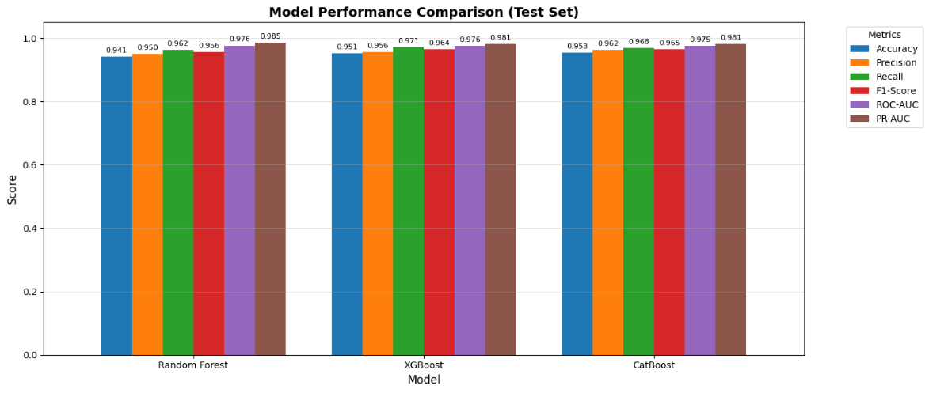
CatBoost delivered the highest accuracy (0.953) and precision (0.962), with a recall of 0.968 and an F1-score of 0.965. Its ROC-AUC (0.975) and PR-AUC (0.981) are nearly identical to XGBoost, reflecting balanced performance. Overall, all three models demonstrate excellent reliability, with CatBoost showing a slight edge in accuracy and F1-score; hence, it is selected as the best-performing model.
Figure 1: Model Comparison

3.3 Best Parameters
The best parameter of the best-performing model - Catboost is shown in the table below.
Parameter | Value
learning_rate | 0.1
l2_leaf_reg | 1
iterations | 400
depth | 11
border_count | 64
bagging_temperature | 0

3.4 SHAP Analysis
Aligning with the above findings, SHAP analysis is then performed on Catboost model’s result. Figure 2 shows the top 10 features distributional impact, while Figure 3 demonstrates their importance values and rankings.
The features weekend_ratio, night_play_ratio, and active_days_ratio emerge as the most influential, exhibiting large mean absolute SHAP values, wide horizontal dispersions, and clear color gradients. This combination indicates not only strong overall impact but also substantial variability in how these features affect different users. Other temporal behavior indicators, such as avg_hour_of_day and peak_hour, display consistent directional patterns, with higher values tending to push predictions upward and lower values pulling them downward, suggesting that later-day activity is particularly predictive of the target outcome. Features related to recency and behavioral diversity, including recency_days and hour_entropy, show narrower spreads yet still provide meaningful and stable contributions, pointing to consistent patterns in user behavior. Finally, engagement-volume and consistency features, such as total_sessions, activity_days, and first_vs_avg_ratio, exert moderate but reliable influence, reflected in their more compact SHAP distributions. Together, these patterns highlight the multifaceted behavioral signals driving the model’s predictive decisions.

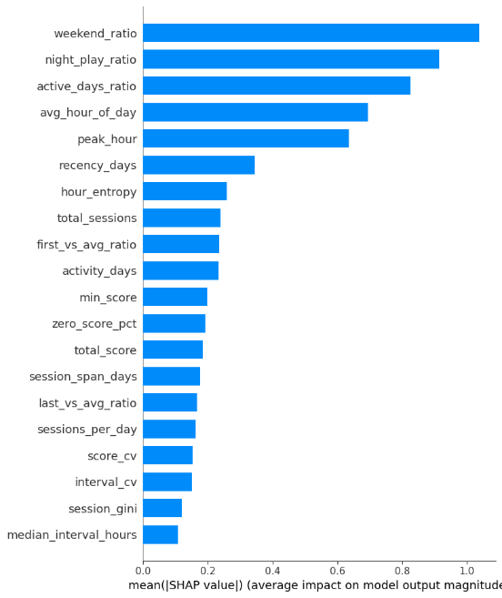

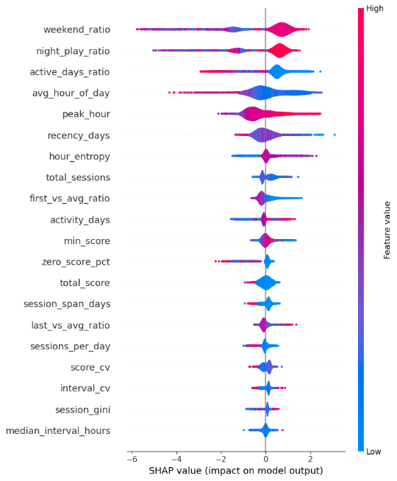
Figure 2: SHAP Beeswarm

Figure 3: SHAP Importance Ranking

4. Discussion
The results demonstrate that early player behavior in Dodge the Mud provides a strong basis for predicting long-term churn. CatBoost emerged as the best-performing model, which aligns with its strength in handling complex interactions and categorical features. However, Random Forest and XGBoost also delivered high performance, indicating that the problem is well suited to tree-based ensemble methods.
The main methodological challenge involved addressing the extreme class imbalance, several imbalance-handle methods have been deployed to increase the performance of minor class such as SMOTEENN and SMOTETeek, but hybrid approach (SMOTE + cost-learning) is the best way to handle this issue.

inherent in many OP/CP combinations. In the end, the choice of OP = 7 and CP = 14 offered an effective trade-off between performance and label reliability. This experiment highlights that varying the window can substantially change the results and model interpretability (Bugajev, Kriauzienė, Vasilecas & Chadyšas, 2022) and that beyond a certain length of memory window (history), additional data yields diminishing returns (Ballings & Van den Poel, 2012).
Feature engineering also played a critical role. While many features were initially created, only a small subset contributed meaningfully to model performance, demonstrating that player behavior during the early stages of the game is relatively simple and can be captured effectively by a compact set of features.
SHAP analysis reveals that temporal features are the most influential predictors in the models. This observation is consistent with Chen et al. (2018), who demonstrated that time-aware models achieve higher predictive accuracy than single-frequency approaches when modeling user behaviors. More recently, Peters, Liu, Barbieri, et al. (2023) extended this insight by showing that temporal-behavioral patterns capture non-redundant variance beyond static usage features, thereby enhancing the performance of deep LSTM neural networks.
Regarding the limitations, SMOTE partially mitigated imbalance but still introduces synthetic noise. The dataset is limited to three raw features; additional contextual variables (e.g., in-game events, social interactions) might improve accuracy. For future, ,ore complex model like sequence models LSTM or transformers can my capture the temporal dependencies more explicitly.

5. Conclusion
This study successfully developed a predictive model for identifying player churn in Dodge the Mud. After evaluating several OP/CP configurations, mitigating class imbalance, engineering relevant features, and testing multiple tree-based models, CatBoost demonstrated the best overall performance. The findings show that player activity within the first seven days is highly informative for predicting future churn and that careful design of labeling windows is crucial for building robust churn prediction models. These insights can support game designers in developing more effective retention strategies and tailoring interventions for at-risk players.

6. References
Ballings, Michel & Van den Poel, Dirk. (2012). Customer event history for churn prediction: How long is long enough?. Expert Systems with Applications. 39. 13517–13522. 10.1016/j.eswa.2012.07.006.
Breiman, L. (2001). Random forests. Machine Learning, 45(1), 5–32.
Bugajev, Andrej & Kriauzienė, Rima & Vasilecas, Olegas & Chadysas, Viktoras. (2022). The Impact of Churn Labelling Rules on Churn Prediction in Telecommunications. Informatica. 1-31. 10.15388/22-INFOR484.
Chen, T., & Guestrin, C. (2016). Xgboost: A scalable tree boosting system. Proceedings of the 22nd ACM SIGKDD International Conference on Knowledge Discovery and Data Mining, 785–794.
Charles Chen, Sungchul Kim, Hung Bui, Ryan Rossi, Eunyee Koh, Branislav Kveton, and Razvan Bunescu. 2018. Predictive Analysis by Leveraging Temporal User Behavior and User Embeddings. In Proceedings of the 27th ACM International Conference on Information and Knowledge Management (CIKM '18). Association for Computing Machinery, New York, NY, USA, 2175–2182. https://doi.org/10.1145/3269206.3272032
Dorogush, A. V., Ershov, V., & Gulin, A. (2018). CatBoost: gradient boosting with categorical features support. Advances in Neural Information Processing Systems (NeurIPS) Workshop.
Peters, H., Liu, Y., Barbieri, F., Abdul Baten, R., Matz, S. C., & Bos, M. W. (2023). Context-aware prediction of user engagement on online social platforms. arXiv preprint arXiv:2310.14533.
(Runge & Gao, 2014).

Declarations statement
State here what each team member contributed toward completing the project, indicating the name and the surname of the team member where applicable.
Code (Preprocess, EDA, Train models): Le Anh Thu Pham
Code (Hyperparameter tuning, OP/CP comparison, Visualization, Feature importance): Lam Minh Triet Thien
Writing (Problem statements, Methodology, Conclusion): Le Anh Thu Pham
Writing (Results, Discussion): Lam Minh Triet Thien
State here your use of Generative AI tools (which specific ones were used, if any, and what you used them for).
- Use Claude to make some visualizations better, to clean the code, fix bug.
- Use ChatGPT to suggest methods to handle the class imbalance, and we tried different methods and comparison to decide the final method

